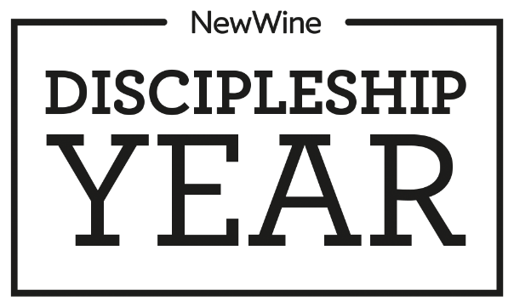

2017/18 APPLICATION FORM

Please select your top 3 New Wine Training Centres for training
(1 being your first choice)
- __________________________________________
- __________________________________________
- __________________________________________

Which church are you hoping to do your Discipleship Year placement at?
_____________________________________________________________________________________

- About You

First names: _________________________ Surname: _______________________________
Date of birth: _____ / _____ / _____ Male Female
Marital status: _________________________ Number of dependents: ____________________
Present occupation: __________________________________________________________________________
Permanent contact address: ___________________________________________________________________
_____________________________________________________________________________________________
Post code: _________________________
Tel day: ___________________________ Tel eve: _______________________________
Mobile: ___________________________ Email: _________________________________
Present address if different: ___________________________________________________________________
_____________________________________________________________________________________________
Post code: ___________________________

2. Your education (starting with most recent)
Dates | University/college | Course | Qualification

from to

School | Subjects | Grades

3. Your employment
dates |  |  | Company/ | Job title/description | Reason for leaving
 |  |  | organization | of role
from |  | to

4. Your church

Current Church: ___________________________ Time at this church? Years ______ Months _____

Church address: ________________________________________________________________________

Pastor’s name: ____________________________ Are you in a small group / cluster: _______________

Please briefly outline your involvement with this church:

__________________________________________________________________________________________

__________________________________________________________________________________________

__________________________________________________________________________________________

__________________________________________________________________________________________

5. Your spiritual journey

Please describe how you became a Christian (use a separate sheet if necessary):

__________________________________________________________________________________________

__________________________________________________________________________________________

__________________________________________________________________________________________

__________________________________________________________________________________________

__________________________________________________________________________________________

__________________________________________________________________________________________

__________________________________________________________________________________________

__________________________________________________________________________________________

__________________________________________________________________________________________

Please outline your journey since then, highlighting key experiences that have developed/grown your faith (use a separate sheet if necessary):

__________________________________________________________________________________________

__________________________________________________________________________________________

__________________________________________________________________________________________

__________________________________________________________________________________________

__________________________________________________________________________________________

__________________________________________________________________________________________

__________________________________________________________________________________________

__________________________________________________________________________________________

__________________________________________________________________________________________

__________________________________________________________________________________________

__________________________________________________________________________________________

__________________________________________________________________________________________

6. Your passions

Why are you interested in the New Wine Discipleship Year?

__________________________________________________________________________________________

__________________________________________________________________________________________

__________________________________________________________________________________________

__________________________________________________________________________________________

__________________________________________________________________________________________

__________________________________________________________________________________________

What do you hope to get out of this year? (e.g. learning, experience, personal growth)

__________________________________________________________________________________________

__________________________________________________________________________________________

__________________________________________________________________________________________

__________________________________________________________________________________________

Do you already have aspirations or ideas about what you might do after the year?

__________________________________________________________________________________________

__________________________________________________________________________________________

__________________________________________________________________________________________

__________________________________________________________________________________________

__________________________________________________________________________________________

7. Your interests

Please briefly describe you interests, hobbies and other recreational activities:

__________________________________________________________________________________________

__________________________________________________________________________________________

__________________________________________________________________________________________

8. Your Schedule

The New Wine Discipleship Year is a part time commitment of 20 hours a week (8 hours of teaching and 12 hours of serving, which may include up to 4 hours on a Sunday).

Where would you like to serve your internship (i.e., which ministry):

Children Yes / No

Youth Yes / No

Students Yes / No

Worship Yes / No

Administration Yes / No

Evangelism Yes / No

Family outreach Yes / No

Creative media Yes / No

Church operations Yes / No

Other Describe…. ____________________________________________________________

Do you have any preference about which days of the week you would like to serve your internship?

__________________________________________________________________________________________

9. Your point of contact

Have you already approached a New Wine Training Centre / church / pastor / internship supervisor about getting involved the 2015-16 Discipleship Year?

Yes / No

If yes, please state who/where:

__________________________________________________________________________________________

__________________________________________________________________________________________

10. Your finances

How do you propose to finance yourself during the Discipleship Year?

__________________________________________________________________________________________

__________________________________________________________________________________________

__________________________________________________________________________________________

__________________________________________________________________________________________

__________________________________________________________________________________________

11. Your history

Please state the nature of any health problems or disabilities that you have including any regular medication that you are currently taking or anything further you think we may need to know:

__________________________________________________________________________________________

__________________________________________________________________________________________

__________________________________________________________________________________________

Have you ever been convicted of a criminal offence, or do you have any pending convictions?

Yes / No

If yes, please give details: ___________________________________________________________________

_________________________________________________________________________________________

12. Your references (these people will be contacted prior to your interview)

Church leader (small group/cluster/pastor) Personal (another church member)

Name: __________________________________ Name: ________________________________

Position: ________________________________ Position: ______________________________

Address: ________________________________ Address: ______________________________

________________ Post code: _____________ ________________ Post code: ____________

Tel day: _________________________________ Tel day: ________________________________

Tel eve: _________________________________ Tel eve: ________________________________

Email: __________________________________ Email: _________________________________

13. Your word

I confirm that the information I have given on this form is accurate and true:

Signed: _________________________________ Date: __________________________________

Once completed, please return to your first-choice New Wine Training Centre.

If your first-choice Centre is full, your application will be forwarded on to your other Centres

